COMP 122-Assignment2

1. Create a directory “dir1” under your home directory. I created one under 2011 under my home directory**. /usr/home/staff3/71/waechter/2011/dir1**

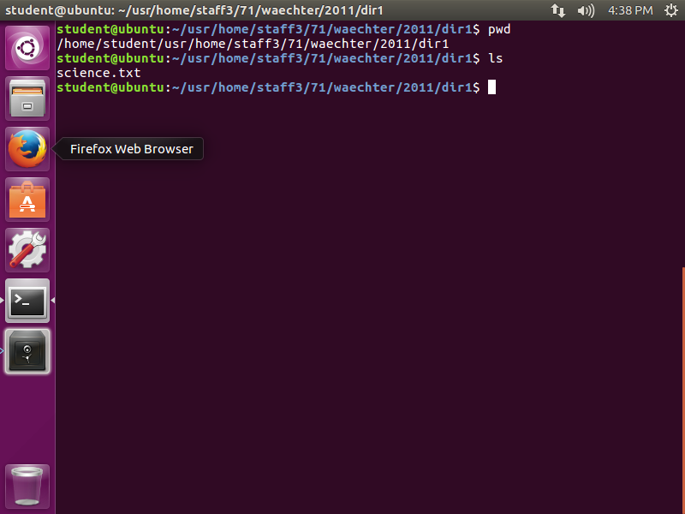

1. Copy the science.txt file from my directory to your dir1 directory.

* First move to my directory.
* cd /usr/home/staff3/71/waechter/2011/dir1
* copy the science.txt file to your subdirectory.
* The simplest way to do this is:

cp science.txt ~/dir1

**Note: the use of the “~” key**

**>echo ~** More on the echo command later

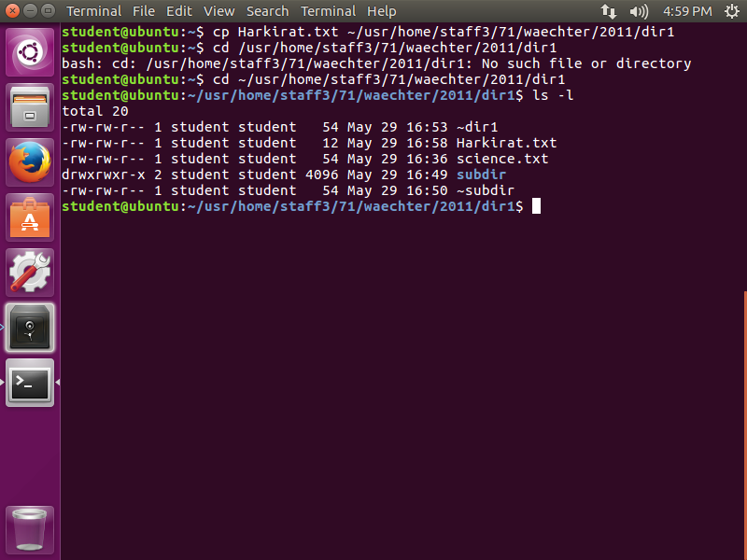

1. What does the “~” key represent? _______________________________________
2. Displaying the contents of a file. There are several ways to display the contents of text files. Several commands are given here:

**>cat science.txt >less science.txt >more science.txt**

Given the results of the following:

>cat science.txt | wc –l _____3______ >less science.txt|wc –l _______3______

>more science.txt|wc –l _____3_____ >head science.txt|wc –l ________3____

>head -5 science.txt| wc –l ____3____ >tail science.txt|wc –l _________3____

>tail -5 science.txt | wc –l _____3____

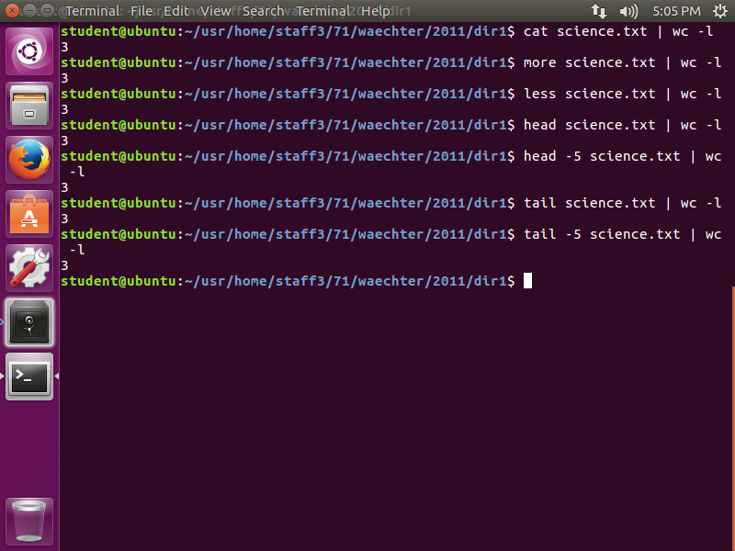

**Note: >less science.txt and >cat science.txt|less give the same output.**

1. Comparing files: There are two unix utilities that compare files: cmp and diff

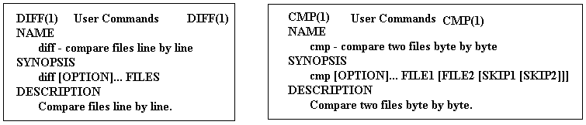

How many **lines** of output are produced by executing each of the following commands?

>diff names names_space ____________11______________

>diff names_space names_tab _______________11___________

>diff names names ______________(NULL)____________

>cmp names names_space byte 7, line 1

>cmp names_space names_tab byte 7, line 1

>cmp names names ____________(NULL)______________

1. Redirection: The use of **“> and >>”**. Perform the following tasks and answer the questions below.

>cat names >ex1 The > key redirects the output to a file.

>cat names >>ex1 the >> keys are used to append to an existing file.

How many lines are now in the ex1 file? _____4______ use wc –l

> cat names names_tab >> ex1 How many lines are now in the ex1 file?

______11_____ use wc –l

1. **The cut command:** Give the output for each of the following: Give at least one record for each.

The cut command takes a vertical slice of a file, printing only the specified columns or fields.

Content of the company.data file:

406378:Sales:Itorre:Jan

031762:Marketing:Nasium:Jim

636496:Research:Ancholie:Mel

396082:Sales:Jucacion:Ed

If you want to print just columns 1 to 6 of each line (the employee serial numbers), use the -c1-6 flag, as in this command:

cut -c1-6 company.data

406378

031762

636496

396082

And since this file obviously has fields delimited by colons, we can pick out just the last names by specifying the -d: and -f 3 flags, like this:

cut -d: -f 3 company.data

Itorre

Nasium

Ancholie

Jucacion

>cut -b1,4 names >cut -b1,4 names >cut -b 9-15 names_space

43 43 :Sales1

07 07 :Market

64 64 :Reasear

30 30 :Sales1

>cut –b 9-15 names_tab >cut –b 19-16 names >cut –d: -f2 names

:Sales1 Invalid decreasing range Sales

:Market Invalid decreasing range Marketing

:Resear Invalid decreasing range Research

:Sales1 Invalid decreasing range Sales

>cut –f1 names_space >cut –f1 names_tab >cut –f1 names

Sales1 Sales12 406378:Sales:Itorre:Jan

Marketing1 Marketing12 031762:Marketing:Nasium:Jim

Research1 Research12 636496:Research:Ancholie:Mel

Sales1 Sales12 396082:Sales:Jucacion:Ed

What is the default field delimiter when using cut? ______comma______

1. **The paste command: paste - merge lines of files: >ex2**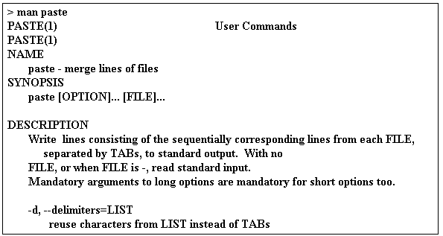

**file1:**

**Jack Wallen**

**Jessica Wallen**

**Johnny Wallen**

**Jeri Wallen**

**The contents of file2 will look like:**

**123-45-6789**

**234-56-7890**

**345-67-8901**

**456-78-9012**

**by running the command paste file1 file2 > file3 and then viewing the file, the contents of file3 will look like Table A.**

**Table A**

**Jack Wallen 123-45-6789**

**Jessica Wallen 234-56-7890**

**Johnny Wallen 345-67-8901**

**Jeri Wallen 456-78-9012**

1. Give the output for each of the following: Give at least one record for each.

>paste names names_space > ex2

>cat ex2

406378:Sales:Itorre:Jan 40637812:Sales12:Itorre12:Jan12

031762:Marketing:Nasium:Jim 03176212:Marketing12:Nasium12:Jim12

636496:Research:Ancholie:Mel 63649612:Research12:Ancholie12:Mel12

396082:Sales:Jucacion:Ed 39608212:Sales12:Jucacion12:Ed12

>cut –f1 ex2

406378:Sales:Itorre:Jan

031762:Marketing:Nasium:Jim

636496:Research:Ancholie:Mel

396082:Sales:Jucacion:Ed

>cut –f2 ex2

40637812:Sales12:Itorre12:Jan12

03176212:Marketing12:Nasium12:Jim12

63649612:Research12:Ancholie12:Mel12

39608212:Sales12:Jucacion12:Ed12

>paste –d: names names_space > ex3

>cat ex3

406378:Sales:Itorre:Jan:40637812:Sales12:Itorre12:Jan12

031762:Marketing:Nasium:Jim:03176212:Marketing12:Nasium12:Jim12

636496:Research:Ancholie:Mel:63649612:Research12:Ancholie12:Mel12

396082:Sales:Jucacion:Ed:39608212:Sales12:Jucacion12:Ed12

:

>cut –f1 ex3

406378:Sales:Itorre:Jan:40637812:Sales12:Itorre12:Jan12

031762:Marketing:Nasium:Jim:03176212:Marketing12:Nasium12:Jim12

636496:Research:Ancholie:Mel:63649612:Research12:Ancholie12:Mel12

396082:Sales:Jucacion:Ed:39608212:Sales12:Jucacion12:Ed12

:

>cut –f2 ex3

406378:Sales:Itorre:Jan:40637812:Sales12:Itorre12:Jan12

031762:Marketing:Nasium:Jim:03176212:Marketing12:Nasium12:Jim12

636496:Research:Ancholie:Mel:63649612:Research12:Ancholie12:Mel12

396082:Sales:Jucacion:Ed:39608212:Sales12:Jucacion12:Ed12

:

1. **The join command: (join lines of two files on a common field)**

**The join command is like the paste command—only a bit more intelligent. The join command takes two files and merges their columns—as long as both files share a common field.**

**% join file1 file2 > file3**

**If the content of file1 is:**

**1 Barbara**

**2 Peter**

**3 Stan**

**4 Marie**

**and file2 is:**

**2 Dog**

**4 Car**

**7 Cat**

**the resulting file3 would be:**

**2 Peter Dog**

**4 Marie Car**

Execute this command: **>join -t: names products > ex4**

How many records in the ex4 file? ____________4_____________

1. **The sort command: The sort command, as its name implies, will sort data according to the users’ needs.**

**The sort command does have a number of useful switches. The sort switches include:**

**-d Sorts only blanks and alphanumeric characters**

**-f Ignores case**

**-I Ignores nonprinting characters**

**-M Sorts by month**

**-n Sorts numerically**

**-r Reverses the sort order**

**-k Starts at a user-defined position and ends at a user-defined position**

**ls -al | sort -n -k 5**

**This results in the following ls command sorted output, which as you can see, is a directory listing, sorted by file size (the 5th column):**

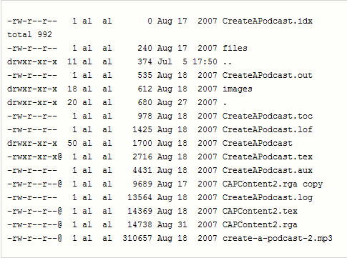

Give the output of each of the following:

**>**sort –k 2 names_tab

0317621:Marketing1:Nasium1:Jim1

3960821:Sales1:Jucacion1:Ed1

4063781:Sales1:Itorre1:Jan1

6364961:Research1:Ancholie1:Mel1

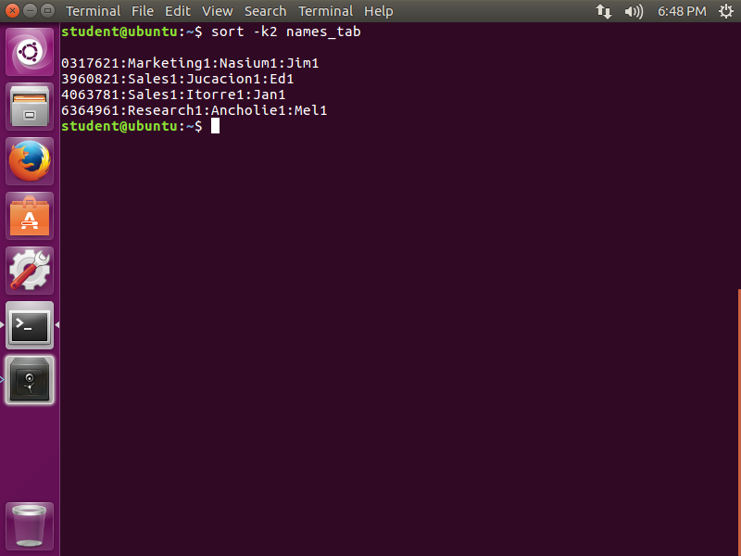

>sort –k 2 –t: names

031762:Marketing:Nasium:Jim

636496:Research:Ancholie:Mel

406378:Sales:Itorre:Jan

396082:Sales:Jucacion:Ed

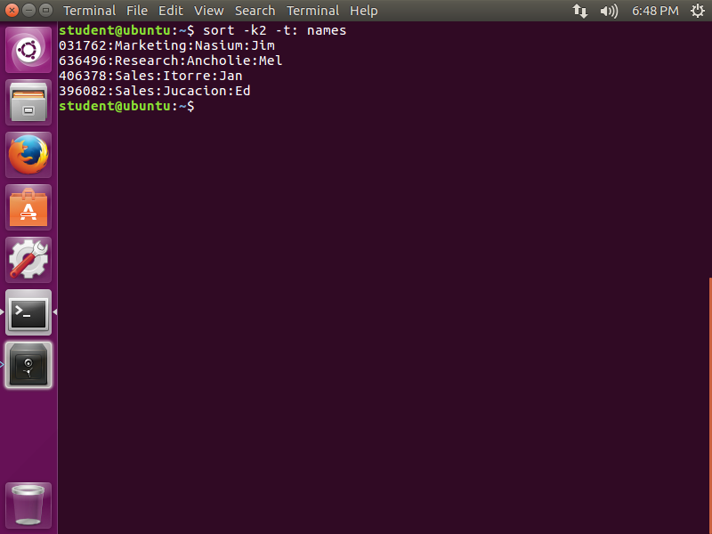

1. **Using inter process communication: “pipe |”**

The output from one process and be used as input to another process. We have already seen this with the **ls –l|wc –l command.**

Now consider:

>cut –d: -f 2 names | sort

Marketing

Research

Sales

Sales

>cut -d: -f 2 names | sort | wc -l

4